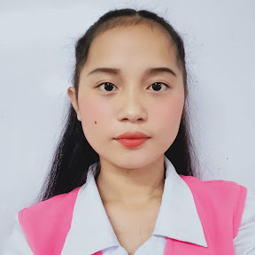
dfh
DEANN MAY U.
MACAS

ABOUT ME
CONTACT
To secure a responsible career opportunity to fully utilize my training and skills, while making a significant contribution to the success of the company

09678828234

deannmaym@gmail.com



DAISY C. BACTOL
Teacher
0963-983-9240

CHARMINE SEIZ
Teacher
0967-586-1809
SKILSS
WORK EXPERIENCE
PARAGUYA FARM
Work Immersion
Poblacion Impasugong Bukidnon
2023
Communication
Leadership
Flexible

Northern Bukidnon Sate Collage
Bachelor of Science in Business Administration Major in Marketing Management
2026-2027-Present

Impasugong National High School
(TVL- Agri-Fishery and Arts) (2022-2023

Impasugong National High School
2017-2022

Kisolon Central Elementary School
2010-2017

CHARACTER REFERENCES
EDUCATION
Deann May U. Macas

